**Exercise 2: Implementing Dependency Injection**

**Scenario:**

In the library management application, you need to manage the dependencies between the BookService and BookRepository classes using Spring's IoC and DI.

**STRUCTURE:**

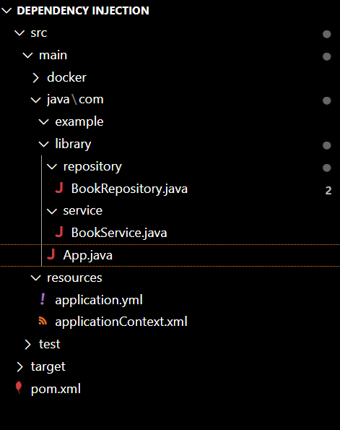

**BookRepository.java**

package com.example.library.repository;

public class BookRepository {

    public void saveBook(String bookName) {

        System.out.println("Book saved: " + bookName);

    }

}

**BookService.java**

package com.library.service;

public class BookService {

    public void displayBooks() {

        System.out.println("Books listed successfully!");

    }

}

**App.java**

package com.library;

import com.library.service.BookService;

public class App {

    public static void main(String[] args) {

        BookService bookService = new BookService();

        bookService.displayBooks();

    }

}

**applicationContext.xml**

<?xml version="1.0" encoding="UTF-8"?>

<beans xmlns="http://www.springframework.org/schema/beans"

       xmlns:xsi="http://www.w3.org/2001/XMLSchema-instance"

       xsi:schemaLocation="

         http://www.springframework.org/schema/beans

         http://www.springframework.org/schema/beans/spring-beans.xsd">

    <!-- Repository bean -->

    <bean id="bookRepository" class="com.example.library.repository.BookRepository" />

    <!-- Service bean with setter-based DI -->

    <bean id="bookService" class="com.example.library.service.BookService">

        <property name="bookRepository" ref="bookRepository" />

    </bean>

</beans>

**Pom.xml**

<project xmlns="http://maven.apache.org/POM/4.0.0"

         xmlns:xsi="http://www.w3.org/2001/XMLSchema-instance"

         xsi:schemaLocation="http://maven.apache.org/POM/4.0.0

         http://maven.apache.org/xsd/maven-4.0.0.xsd">

  <modelVersion>4.0.0</modelVersion>

  <groupId>com.library</groupId>

  <artifactId>LibraryManagement</artifactId>

  <version>1.0-SNAPSHOT</version>

  <dependencies>

    <!-- Spring Core -->

    <dependency>

      <groupId>org.springframework</groupId>

      <artifactId>spring-context</artifactId>

      <version>5.3.36</version>

    </dependency>

  </dependencies>

  <build>

    <plugins>

      <!-- Compiler plugin -->

      <plugin>

        <groupId>org.apache.maven.plugins</groupId>

        <artifactId>maven-compiler-plugin</artifactId>

        <version>3.8.1</version>

        <configuration>

          <source>1.8</source>

          <target>1.8</target>

        </configuration>

      </plugin>

    </plugins>

  </build>

</project>

**OUTPUT:**

